**RAISE_DONATION-**

**THE ONLINE DONATING SITE**

***A project report of***

**Bachelor of Computer Applications**

**VIth Semester**

## Jan - May, 2020

**Project Guide Submitted By**

Er.Hitesh Ninama Ravindra Raghuwansi

1710148

Shubham Kumar Jha

1710163

**School of Computer Science & Information Technology**

**Devi Ahilya Vishwavidyalaya, Indore, M.P**

**2020**

**School of Computer Science & Information Technology**

**Devi Ahilya Vishwavidyalaya, Indore, M.P.**

**DECLARATION**

I hereby declare that the project titled “**Online Donating Site**” submitted by me for *Bachelor of Computer Applications* VIth semester to *School of Computer Science & Information Technology, Devi Ahilya Vishwavidyalaya, Indore,* comprises my own work and due acknowledgement has been made in text to all other material used.

Signature of Student: ………………………

Name: Ravindra Raghuwanshi

Signature of Student: ………………………

Name: Shubham Kumar Jha

Date ……………………………………..

**School of Computer Science & Information Technology**

**Devi Ahilya Vishwavidyalaya, Indore, M.P.**

**CERTIFICATE FROM GUIDE**

It is to certify that the project entitled “**Online Donating Site**” submitted by **Mr. Ravindra Raghuwanshi** and **Mr. Shubham Kumar Jha** to the *School of Computer Science & Information Technology, Devi Ahilya Vishwavidyalaya, Indore* has been completed under my supervision and the work is carried out and presented in a manner required for its acceptance to *Bachelor of Computer Applications VIth semester*.

**Project Guide**

Signature: ………………………..

**Name:** Er. Hitesh Ninama

Date: ………………………..

**School of Computer Science & Information Technology**

**Devi Ahilya Vishwavidyalaya, Indore, M.P.**

**EXAMINATION APPROVAL CERTIFICATE**

It is to certify that we have examined the project entitled “**Online Donating Site**”, submitted by **Mr. Ravindra Raghuwanshi** and **Mr. Shubham Kumar Jha** to the *School of Computer Science & Information Technology, Devi Ahilya Vishwavidyalaya, Indore* and hereby accord our approval of it as a study carried out and presented in a manner required for its acceptance *Bachelor of Computer Applications VIth semester.*

**Internal Examiner External Examiner**

Signature**:** Signature**:**

Name  **:** Name **:**

Date **:** Date  **:**

## ACKNOWLEDGEMENT

We take this occasion to thank God, almighty for blessing us with his grace and taking our endeavor to a successful culmination. We extend our sincere thanks to our respected **Head of the Department, Dr. Sanjay Tanwani**, for allowing us to use the facilities available. We also take this opportunity to express a deep sense of gratitude to our class coordinator and project coordinator, **Er. Hitesh Ninama** for his cordial support, valuable suggestions and guidance.

We also extend our sincere and heartfelt thanks to him for providing us with the right guidance and advice at the crucial junctures and for showing us the right way. We would like to thank the other faculty members also, at this occasion.

Last but not the least, we would like to thank our friends and family for the support and encouragement they have given us during the course of our work.

**ABSTRACT**

Online Donating site is web-based software that helps to donate resources like food, clothes, books etc online. It is an ideal for Home, Society, Industries, School, Hospitals, Factories, Offices based. The Online Donating site allows user through internet to register and donate those stuffs or resources which are not of their use and might be useful to others.The Online Donating site allow NGOs to register themselves so that they can reach at those places where there is any requirement of food, clothes or books etc. This System provides a platform to donate resources or things online. The online Donating site will act as a mediator between donor and NGO, for the convenince of both which results into proper satisfaction and utilization of time.

**TABLE OF CONTENTS**

|  |  |  |
| --- | --- | --- |
| **S.No** | **Topic** | **Page Number** |
| **1.** | Introduction   * 1. Intro   2. Existing System   3. Proposed System   4. Purpose   5. Aim   6. Objectives   7. Benefits | 1-3  1  1  2  2  3  3  3 |
| **2.** | Project Planning  **2.1** Project Schedule   * 1. Development Plan   2. Project Deliverables   3. User Requirement   4. Business Requirements   5. Gantt Chart   6. **Hardware Requirements**   7. **Software Requirements**   8. Tools and Environment setup | 4-9  4  4  5  5  6  7  7  7  8-9 |
| **3.** | System Analysis   * 1. System analysis   2. Problem Statement   3. Feasibility Analysis   4. Requirement Specification | 10-15  10  10  11-13  14-15 |
| **4.** | System Design   * 1. Software Development Methodology   2. Requirement Analysis   3. Data Flow Diagram   4. Use Case Diagram   5. Entity Relationship Diagram   6. Database schema | 16-23  17  18  19-20  21  22  23 |
| **5.** | System Implementation   * 1. Plans   2. Details of modules and their abstraction   **5.3** Snapshots(Output Forms) | 24-34  24  24  25-34 |
| **6.** | System Testing | 35-36 |
| **7.** | Conclusion  **7.1** Conclusion  **7.2** Limitations | 37  37  37 |
| **8.** | Lesson Learned and Future Scope  **8.1** Lesson Learned   * 1. Scope   2. References | 38-39  38  38  39 |

**LIST OF FIGURES**

Figure 1: Gantt Chart ----------------------------------------------------------------------------------6

Figure 2: V Model ------------------------------------------------------------------------------------17

Figure 3: Level 0 DFD--------------------------------------------------------------------------------19

Figure 4: Level 1 DFD -------------------------------------------------------------------------------20

Figure 5: Use Case Diagram-------------------------------------------------------------------------21

Figure 6: ER diagram---------------------------------------------------------------------------------22

Figure 7: Home page(part 1) -------------------------------------------------------------------------25

Figure 8: Home page(part 2) -------------------------------------------------------------------------25

Figure 9: Home page(part 3) -------------------------------------------------------------------------26

Figure 10: Registration Form(User) ------------------------------------------------------------------26

Figure 11: Login Form(Donor) -----------------------------------------------------------------------27

Figure 12: Registration Form(NGO) -----------------------------------------------------------------27

Figure 13: Login Form(NGO) ------------------------------------------------------------------------28

Figure 14: Forget Password Form --------------------------------------------------------------------28

Figure 15: OTP Form -----------------------------------------------------------------------------------29

Figure 16: About NGOs Page -------------------------------------------------------------------------29

Figure 17: User & NGO pannel (Overview) --------------------------------------------------------30

Figure 18: User & NGO pannel (part 2) -------------------------------------------------------------30

Figure 19: Request Form -------------------------------------------------------------------------------31

Figure 20: Donation History ---------------------------------------------------------------------------31

Figure 21: Donation Form -----------------------------------------------------------------------------32

Figure 22: Edit Form(Change Password) ------------------------------------------------------------33

Figure 23: Edit Form(Basic Details) -----------------------------------------------------------------33

Figure 24: Notification Page -------------------------------------------------------------------------- 34

Figure 25: Your Request Page------------------------------------------------------------------------ 34

CHAPTER-1

Introduction

Introduction aims to describe the project background, problem statement, objectives, project significance, scope and expected output of the system. The system is **Online Donating Site** called as **RAISE_DONATION**. This system is a solution for managing & donating the stuffs or resources.. This system centralizes all by providing features to its Users, Donors, and NGOs. Data in the system can be analysed, graphed and reported in the format of user's choice. System provides the direct communication platform between Donors and NGOs.

Online Donating site is web-based software that helps you to donate resources like food, clothes, books etc online.

It is an ideal for Home, Society, Industries, School, Hospitals, Factories, Offices based. The Online Donating site allows user through internet to register and donate those stuffs or resources which are not of their use and might be useful to others.The Online Donating site allow NGOs to register themselves so that they can reach at those places where there is any requirement of food, clothes or books etc. This System provides a platform to donate resources or things online. The online Donating site will act as a mediator between donor and NGO, for the convenince of both which results into proper satisfaction and utilization of time.

.

**1.1 Existing System**

The existing system is not computerized or if it is, then there is no platform for all type or category of donation. To make this system online for donors and as well as for NGOs task to make easy and comfortable. Earlier Donor find difficulties to reach out at the location of NGOs and the same problem comes with NGOs to collect any donations. And there is no online way to solve this.

For example, in the existing system Donor can only donate through money to the NGOs, and if he/she has to donate other stuffs like Foods, Clothes, Books they have find the that spot or to find that Ngo of that particular sector which is quite complex for donors.

Second thing is Donor may have trust issues with the NGO as he/she might be donating first time so they feel uncomfortable. Everytime donor have to reach at the location for donating their stuffs which may cause some inconvinience to the donors like finding the location, carrying those stuffs, utility of time etc.

**1.2 Proposed System**

In this online donation website, donor can donate resources like food,clothes,blood etc online. It is an ideal for Home, Society, Industries, School, Hospitals, Factories, Offices based.The Online Donating site allows Donors, through Internet, to register, or donate those stuffs or resources which are not of their use and might be useful to others.

And this also allow NGOs to register themselves so that they can reach at those places where there is any requirement of food,clothes,any health issue etc. This System provides a platform to Sell or donate waste or unwanted things online.

In this system user can register to get login id and password. With login id and password user can get logged in. There will be two modules:

* 1. User module
  2. NGO’s module

After logging in or regestering, User can use the features of whole system. Donor can views his/her contribution and can donate according to his/her availability of resources.

And NGO’s can register themselves so that the resources donated by donors can be handeled to them in order to provide it to the required place of peoples.

Donor have an option of pickup and doorstep. So he/she can donate according to their convenience. If they have a quantity more(based on our terms & condition) our Ngo will reach out at their location to pickup according to the time given bt the donors.

Any visitor after registering onto the site can request for any requirements, so the ngos will be informed to fullfill that requirement if possible.

**1.3 Purpose**

* This system is to minimize the manual work and the maximize the interface between Donors and NGOs.
* This is an online application that can be accessed outside, inside or anywhere.
* This system will provide extra features to Donors and NGOs so that their work force will be reduced.

**1.4 Aim**

The aim of the project is to analyse the requirements of the needy or underprivileged peoples of the society and fulfilling those requirements by taking from donors and giving to the NGOs. This project would provide the efficient way of communication between Donors and NGOs.

**1.5 Objective**

* To provide a proper registration system to the new user and Ngos .
* To make the information accessible to the user at the desk, in just a click away.
* To make the donation process efficient and easy
* To provide easiest platform for the communication between donor and ngos.

**1.6 Benefits**

* Online Donating Site provide up to date information of all the donations maded by the users or donors. This help the NGOs or to us to overcome the difficulty in keeping records of hundreds of donations and transparency would be there.
* Online Donating Site helps the Donors to register and then donate things easily to the NGOs.
* Same with NGOs, then can register themselves as a NGOs which help them to interact with the donors.
* This helps in effective and utilization of the resources and time for both the parties.

CHAPTER-2

project planning

Information systems have become increasingly important during the past decade. First, information is now recognized as a vital resource. Second, more and more financial resources are committed to information systems. Third, there is growing need for formal long range planning with information systems. The most critical phase of managing system projects is planning. It is discipline for stating how to complete a project within a certain timeframe, usually with defined stages, and with designated resources.

**2.1 Project Schedule**

|  |  |  |
| --- | --- | --- |
| **Activity** | **Dates** | **Durations** |
| Project Proposal | 25 Jan – 15 Feb | 21 Days |
| Analysis and Feasibility Study | 16 Feb – 15 Mar | 28 Days |
| System Design | 16 Mar – 15 Apr | 30 Days |
| System Development | 16 Apr – 15 May | 29 Days |
| Testing | 16 May – 31 May | 15 Days |
| Implementation | 1 May – 10 June | 10 Days |
| Report Writing | 11 June – 15 Jul | 35 Days |

**2.2 Development Plan**

The design and implementation of this project has been carried out in a completely stepby- step manner:

• Discussions

• Software Requirement Specifications

• Design Document

• Coding

• Testing

• Project Report

**2.3 Project Deliverables**

**Deliverable** is a term used in project management to describe a tangible or intangible object produced as a result of the project that is intended to be delivered to a User . A deliverable could be report, a document, a word package, a server upgrade or any other building block of an overall project.

The **Online Donating Site** Deliverables are :

**Project Report & Documentation** -

Project report provides an introduction to current system and system to be built. It gives the brief knowledge of current system. A complete documentation is given in the form of SRS. Software Requirement Specification provides an introduction of the current system and the system to be built. This overview includes the purpose of SRS and a brief knowledge of the current system . The overview also provided an introduction of the proposed system.

**2.4 User Requirement**

**User requirements**, often referred to as user needs, describe what the user does with the system, such as what activities that users must be able to perform. User requirements are generally documented in a User Requirements Document (URD) using narrative text. User requirements are generally signed off by the user and used as the primary input for creating system requirements.

An important and difficult step of designing a software product is determining what the user actually wants it to do. This is because the user is often not able to communicate the entirety of their needs and wants, and the information they provide may also be incomplete, inaccurate and self-conflicting. The responsibility of completely understanding what the customer wants falls on the business analyst. This is why user requirements are generally considered separately from system requirements. The business analyst carefully analyzes user requirements and carefully constructs and documents a set of high quality system requirements ensuring that that the requirements meet certain quality characteristics.

**2.5 Business Requirements**

**Business requirements** describe why the organization is undertaking the project. They state some benefits that the developing organization or its customers expect to receive from the product. Business requirements may be delineated in several documents such as a project charter, business case, or in a project vision and scope statements.

Business requirements is a phase in Software development life cycle which felicitates the requirements of the end users as the very first task in order to guide the design of the future system. Business requirements are usually captured by business analysts or product owners who analyze business activities who in turn act as subject matter expertise (SME's).

**2.6 Gantt Chart**

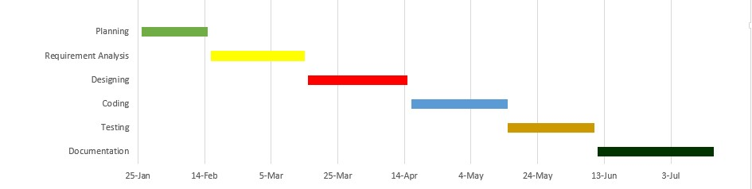

Fig 1: Gantt Chart

**2.7 Hardware Requirements**

* Pentium IV or higher, (PIV-300GHz recommended)
* 256 MB RAM
* 1 Gb hard free drive space

**2.8 Software Requirements**

* OPERATING SYSTEM: Windows 07/08/10
* DATABASE SERVER: MySQL
* FRONT END: HTML, CSS and JS
* BACK END: Python(Django)
* PLATFORM: Pycharm IDE

**2.9 Tools and Environment setup**

**2.9.1 HTML**

HTML is a language for describing the structure of Web pages. HTML stands for Hyper Text Markup Language. Web pages consist of markup tags and plain text. HTML5 is the next generation of HTML.

**2.9.2 CSS**

Cascading Style Sheets, fondly referred to as CSS, is a simple design language intended to simplify the process of making web pages presentable. CSS handles the look and feel part of a web page. Using CSS, you can control the color of the text, the style of fonts, the spacing between paragraphs, how columns are sized and laid out, what background images or colors are used, layout designs, variations in display for different devices and screen sizes as well as a variety of other effects. CSS is easy to learn and understand but it provides powerful control over the presentation of an HTML document. Most commonly, CSS is combined with the markup languages HTML or XHTML.

**Advantages of CSS**

• CSS saves time − You can write CSS once and then reuse same sheet in multiple HTML pages. You can define a style for each HTML element and apply it to as many Web pages as you want.

**Pages load faster** − If you are using CSS, you do not need to write HTML tag attributes every time. Just write one CSS rule of a tag and apply it to all the occurrences of that tag. So less code means faster download times.

• Easy maintenance − To make a global change, simply change the style, and all elements in all the web pages will be updated automatically.

• Superior styles to HTML − CSS has a much wider array of attributes than HTML, so you can give a far better look to your HTML page in comparison to HTML attributes.

• Multiple Device Compatibility − Style sheets allow content to be optimized for more than one type of device. By using the same HTML document, different versions of a website can be presented for handheld devices such as PDAs and cell phones or for printing.

• Global web standards − Now HTML attributes are being deprecated and it is being recommended to use CSS. Soits a good idea to start using CSS in all the HTML pages to make them compatible to future browsers.

**2.9.3 Java Script**

JavaScript is a dynamic computer programming language. It is lightweight and most commonly used as a part of web pages, whose implementations allow client-side script to interact with the user and make dynamic pages. It is an interpreted programming language with object-oriented capabilities. JavaScript was first known as LiveScript, but Netscape changed its name to JavaScript, possibly because of the excitement being generated by Java. JavaScript made its first appearance in netscape 2.0 in 1995 with the name LiveScript. The general-purpose core of the language has been embedded in Netscape, Internet Explorer, and other web browsers. E Learning Education Page 23 The ECMA-262 Specification defined a standard version of the core JavaScript language.

• JavaScript is a lightweight, interpreted programming language.

• Designed for creating network-centric applications.

• Complementary to and integrated with Java.

• Open and cross-platform

**2.9.4** **Django**

Django is a Python-based web framework that allows you to quickly create efficient web applications. It is also called batteries included framework because Django provides built-in features for everything including Django Admin Interface, default database – SQLlite3, etc. When you’re building a website, you always need a similar set of components: a way to handle user authentication (signing up, signing in, signing out), a management panel for your website, forms, a way to upload files, etc. Django gives you ready-made components to use and that too for rapid development.

**Why Django Framework ?**

* Excellent documentation and high scalability.
* Used by Top MNCs and Companies, such as Instagram, Disqus, Spotify, Youtube, Bitbucket, Dropbox, etc. and the list is never-ending.
* Easiest Framework to learn, rapid development and Batteries fully included.
* The last but not least reason to learn Django is [Python](https://www.geeksforgeeks.org/python-programming-language/), Python has huge library and features such as Web Scrapping, Machine Learning, Image Processing, Scientific Computing, etc. One can integrate it all this with web application and do lots and lots of advance stuff.

**2.9.5 MySQL**

MySQL server is a open-source relational database management system which is a major support for web based applications. Databases and related tables are the main component of many websites and applications as the data is stored and exchanged over the web. Even all social networking websites mainly Facebook, Twitter and Google depends on MySQL data which are designed and optimized for such purpose. For all these reasons, MySQL server becomes the default choice for web applications.

MySQL server is used for data operations like querying, sorting, filtering, grouping, modifying and joining the tables.

**Advantages of MySQL :**

* Fast and high Performance database.
* Easy to use, mainitain and administer.
* Easily available and maintain integrity of database.
* Provides scalability, usability and reliability.
* Low cost hardware.
* MySQL can read simple and complex queries and write operations.
* InnoDB is default and widely used storage engine.
* Provides strong indexing support.
* Provides SSL support for secured connections.
* Provides powerful data encryption and accuracy.
* Provides Cross platform compatability.
* Provides minimized code repetition.

**2.9.6 IDE Pycharm :**

PyCharm is the most popular IDE for Python, and includes great features such as excellent code completion and inspection with advanced debugger and support for web programming and various frameworks. PyCharm is created by Czech company, Jet brains which focusses on creating integrated development environment for various web development languages like JavaScript and PHP.

PyCharm offers some of the best features to its users and developers in the following aspects

* Code completion and inspection
* Advanced debugging
* Support for web programming and frameworks such as Django and Flask

CHAPTER-3

System Analysis

**3.1 System analysis**

The Analysis phase is where the project life cycle begins. The Analysis phase is where you break down the deliverables in the high level project charter into more detailed business requirements. It is also the part of the project where you identify the overall direction that the project will take through the creation of project strategy documents.

Gathering Requirements is main factor of the Analysis phase. The process of gathering requirements is usually more than simply asking users what they need and writing their answers down. Depending on the complexity of the project, the process of gathering requirements has clearly defined process of its own. This process consists of a group of repeatable processes that utilize certain techniques to capture, document, communicate and manage requirements. This formal process which will be developed in more detail, consists of four basics steps:

* Elicitation - I ask questions you talk, I listen.
* Validation - I analyze, I ask follow up questions.
* Specification- I document, I ask follow up questions.
* Verification - We all agree.

According to our requirements, we gather all the requirements of the project and collect the all the requirements from various sources like we tried to understand the from varioues other donating sites and their working .

**3.2 Problem Statement**

The problem occurred before having computerized system includes:

* H uman Efforts:

When computerized system is not implemented large amount of human efforts is required to personally go to place and donate anything.

* T ime Wastage:

When a computerized system is not there large amount of time is wasted in going to NGO’s at various unknown location.

* D ifficult To find trusted NGO’s:

When donor is not having the knowledge of any NGO’s regarding their working or existence,it become difficult for donor to trust them.

* Difficult to Donate

No system or sector provide one place or platform to do donation,charity,or to raise fund at one place specially in an online mode .

* Different sectors:

There is no system for donating more than one type stuffs like food, clothes, books .

* Communication:

There is no system which connects one NGO to other NGO.

**3.3 Feasibility Analysis**

An important outcome of the preliminary investigation is the determination that the system requested is feasible. Feasibility study examines how beneficial is the project economically, technically and non technically i.e., under three aspects -

* Economic Feasibility
* Technical Feasibility
* Operational Feasibility

**3.3.1 Economic Feasibility**

Economic feasibility analysis is the most commonly used method for determining the efficiency of a project. It is also known as cost analysis. It helps in identifying profit against investment expected from a project. Cost and time are the most essential factors involved in this field of study. The economic analysis of the project counts for the cost effectiveness of the project which the analysis raise financial and economic questions during preliminary investigation to estimate the following:

* The cost to conduct a full system investigation.
* The cost of hardware and software for the class of application being consider.
* The benefits in the form of reduced costs or fewer costly errors.
* the cost if nothing changes.

The economic feasibility of **Online Donating Site** is measured under the following :

The project fits in the proposed budget and satisfies the economic constraints.This project can be regarded as economically feasible because the Online Donating Site possesses the system with them, So there is no need of bearing any cost on the resources needed for the development of the system. The only cost involved in the project is installation/deployement or promotion cost . The only resources required for proper and successful installation is a computer system meeting software and hardware requirements of the system. These costs and the reources are quite minimal and easily available. In the addition there are no start up costs for communication equipment installations , cost of disruption to the rest of the system.

**3.3.2 Technical Feasibility**

Can the work for the project be done with current equipments , existing software technology and available personnel? If the new technology is needed , what is the likelihood that it can be developed ? There are number of technical issues which are generally raised during the feasibility stage of the investigation. They are as follows:

* Does the necessary technology exist to do what is suggested?
* Does the proposed system has the technical capacity to hold the data required to use the new system?
* Can the system be upgraded if developed?
* Are there technical guarantee of accuracy , reliability , ease of access and security?

The criteria for technical feasibility of **Online Donating Site** are:

**Easy to use :** The users were assumed to be normal ordinary people having knowledge of simple system or mobile , so it will be ease of use for users .

**Security :** All the functions are kept under control of admin , so the authority of the data access will be protected .

**Reliability :** As the collections are used for storing the data, so reliability is maintain as exact data is retrieved . Data is regained from each collection by using a key so the accurate record is accessed.

**Maintainability :** Maintenance usually has updations , as a project is build with keeping in mind all the necessary functions so no essential updation is required. HTML,CSS,JAVASCRIPT and BOOTSTRAP can be updated so that new layouts of data reports can be produced as desired. DJANGO is used at backend so adding up the new functionality or feature would be easy task. Terminals must be updated with antivirus so the proper functioning of operating system can be maintained.

**Portability :** Site can be acceses through any device like computer, tablet, smartphones etc.Only thing is required is internet .

**Reusability :** The project is easily extensibility and portability of this project would make it reusable.

**Extensibility :** The project is easily extensible as Django support further editing , such as adding new feature, services and so on.

**Serviceability :** The project will try to provide maximum possible services to the user.

In our project the technical feasibility is considered up to a great extent. The system is build using Django at beackend and HTML, CSS, JAVASCRIPT at frontend which is freely available . Thus the problem of non availability of software eradicates. The backend database of the system is MySQL, which is efficient database application. Proposed system can be expanded in future if required. Proposed system has the capacity to hold the data of the donors, ngos and their requests, donation. It also provide the data security by protection.

**3.3.3 Operational Feasibility**

Will the system to be used if it is developed and implemented ? Will there be resistance from users that will determine the possible application benefits? Proposed system is beneficial only if there can be turned into information system that will meet the operating requirements of users. Issues that appear to be quite minor at the early stage can grow into major problems after implementation. Therefore, it is advisable to consider operational aspects carefully. Operational feasibility is also known as behavioural feasibility, because it measures the behaviour of users.

Behavioural feasibility of Online Donating Site is the measure that how effective the users use the system. It is one of the major factors of feasibility analysis. The new and the proposed system **Online Donating Site** is:

* Easy to operate
* Secure.
* Convenient in maintenance.
* Effective in its work

The system analyst must consider the behavioural feasibility of the requested Online Donating Site as, it is dependent on the human resources available for the Online Donating Site and involves projecting the system operates and be used when installed . The system is behaviourally feasible as it fulfils the points:

* Online Donating Site is easy to operate.
* In all the areas of application the expanded results are better than earlier.
* Retrieval/Updation of the information is easy and accurate.
* Transaction is easy.
* The system should not crashed or failed.

**3.4 Requirement Specification**

A software requirements specification is a description of a software system to be developed, laying out functional and non functional requirements, and may include a set of use cases that describe interactions the users will have with the software .

**3.4.1 Functional Requirement**

A functional requirements defines a function of the system and its components. A function is described as a set of inputs, the behaviour and its outputs.

The main purpose of functional requirements within the requirement specification document is to define all the activities or operations that take place in the system. These are derived through interactions with the users of the system.

* This system should allow the administrator and user to manage their respective functionality.
* This system should allow the administrator and user to insert, update and delete the details.
* This system should allow the user to view the essential details associated to him .
* This system should allow the administrator to manage the verification process of any user.
* This system should allow the user to register as per their requirement.
* This system should allow the user to send and receive requests.
* This system should allow the user to make any transaction after a complete verification and assure the security of their details.

**3.4.2 Non Functional Requirements**

A non functional requirement is a requirement that specifies criteria that can be used to judge the operation of a system, rather than specific behaviours. Non - Functional Requirements are often called qualities of a system.

Following are the non functional Requirements of **Online Donating Site**:

**Usability**

* We get the responses within the seconds.
* The web application has a simple, user friendly interface so user can save time and without any complexity and confusion.

**Reliability**

* The website is more reliable because of the qualities that are inherited from the platform. The code built by using HTML and CSS at frontend is more reliable

**Supportability**

* The website is designed to be the cross platform supportable. The system is supported on a wide range of hardware and any software platform which is having any web server installed into the system.
* The website is implemented in web environment.

**Interface**

* The user interface is based on the web browser. The website is built using HTML and CSS and Javascript.
* The interface design is aimed at a flexible front end communication to provide the user with clear information in navigating a user friendly interface is planned.

**Security**

* It will allow to changes and updates only by admin.

CHAPTER-4

System design

Software design is a process to transform user requirements into some suitable form, which helps the programmer in software coding and implementation. For assessing user requirements, an SRS (Software Requirement Specification) document is created whereas for coding and implementation, there is a need of more specific and detailed requirements in software terms. The output of this process can directly be used into implementation in programming languages. Software design is the first step in SDLC (Software Design Life Cycle), which moves the concentration from problem domain to solution domain. It tries to specify how to fulfill the requirements mentioned in SRS. Software design yields three levels of results:

* **Architectural Design** - The architectural design is the highest abstract version of the system. It identifies the software as a system with many components interacting with each other. At this level, the designers get the idea of proposed solution domain
* **Logical design** - Logical design pertains to an abstract representation of the data flow, inputs, and outputs of the system. It describes the inputs (sources), outputs (destinations), databases (data stores), procedures (data flows) all in a format that meets the user requirements. While preparing the logical design of a system, the system analyst specifies the user needs at level of detail that virtually determines the information flow into and out of the system and the required data sources. Data flow diagram, E-R diagram modeling are used.
* **Physical Design** - Physical design relates to the actual input and output processes of the system. It focuses on how data is entered into a system, verified, processed, and displayed as output. It produces the working system by defining the design specification that specifies exactly what the candidate system does. It is concerned with user interface design, process design, and data design.

**4.1 Software Development Methodology**

**V-model**

Software development methodology use development methodology to minimize risk (such as bugs, cost overruns, and changing requirements) when adding new functionality. In all methods, we develop the software in iterations that contain mini-increments of the new functionality

Here in this project we use **V model** for better functioning of project

V- model means Verification and Validation model. Just like the waterfall model, the V-Shaped life cycle is a sequential path of execution of processes. Each phase must be completed before the next phase begins. Testing of the product is planned in parallel with a corresponding phase of development in V-model**.**

Under the V-Model, the corresponding testing phase of the development phase is planned in parallel. So, there are Verification phases on one side of the ‘V’ and Validation phases on the other side. The Coding Phase joins the two sides of the V-Model.

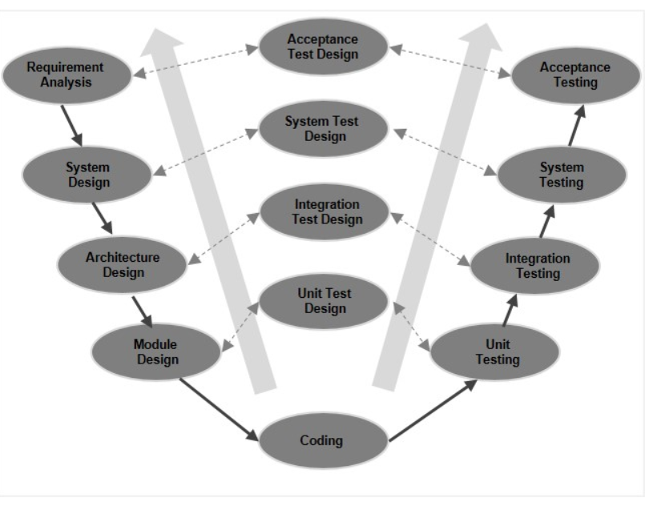

Fig 2: V Model

**4.2 Requirement Analysis**

This is the first phase of our project where we study all the requirement of our project and how to implement them. In this we see all the existing system and try to observe the problems in them and how to solve them. After that there we do acceptance testing where we see that is it practical and feasible to make something like that.

**4.3 System Design**

Once weare clearaboutthe project requirements, it is time to design the complete system. The system design will have the understanding and detailing the complete hardware and communication setup for the product under development. The system test plan is developed based on the system design. Doing this at an earlier stage leaves more time for the actual test execution later.

**4.4 Architectural Design**

Architectural specifications are understood and designed in this phase. Usually more than one technical approach is proposed and based on the technical and financial feasibility the final decision is taken. The system design is broken down further into modules taking up different functionality. This is also referred to as **High Level Design (HLD)**.

The data transfer and communication between the internal modules and with the outside world (other systems) is clearly understood and defined in this stage. With this information, integration tests can be designed and documented during this stage.

**4.5 Module Design**

In this phase, the detailed internal design for all the system modules is specified, referred to as Low Level Design (LLD). It is important that the design is compatible with the other modules in the system architecture and the other external systems. The unit tests are an essential part of any development process and helps eliminate the maximum faults and errors at a very early stage. These unit tests can be designed at this stage based on the internal module designs.

**4.6 Coding Phase**

The actual coding of the system modules designed in the design phase is taken up in the Coding phase. The best suitable programming language is decided based on the system and architectural requirements is Django:Python Framework .

The coding is performed based on the coding guidelines and standards. The code goes through numerous code reviews and is optimized for best performance before the final build is checked into the repository.

**4.7 Data Flow Diagram**

Data flow diagrams are used to graphically represent the flow of data in a business information system. DFD describes the processes that are involved in a system to transfer data from the input to the file storage and reports generation. Data flow diagrams can be divided into logical and physical. The logical data flow diagram describes flow of data through a system to perform certain functionality of a business. The physical data flow diagram describes the implementation of the logical data flow.

**Why DFD?**

DFD graphically representing the functions, or processes, which capture, manipulate, store, and distribute data between a system and its environment and between components of a system. The visual representation makes it a good communication tool between User and System designer. Structure of DFD allows starting from a broad overview and expand it to a hierarchy of detailed diagrams. DFD has often been used due to the following reasons:

* Logical information flow of the system
* Determination of physical system construction requirements
* Simplicity of notation
* Establishment of manual and automated systems requirements

**4.7.1 Level 0 :**

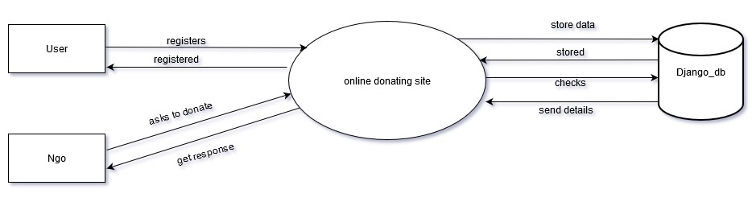

Fig-3: Level 0 DFD

**4.7.2 Level 1:**

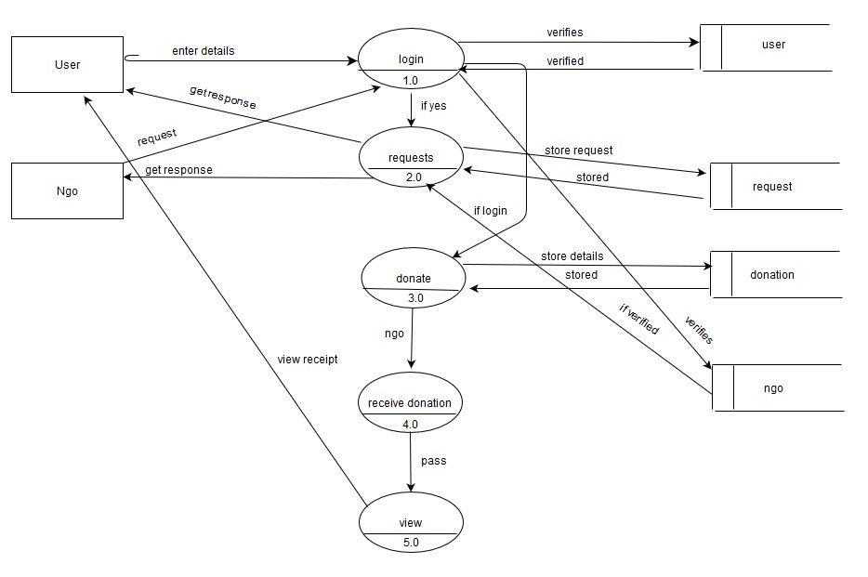

Fig-4: Level 1 DFD

**4.8 Use Case Diagram**

A cornerstone part of the system is the [functional requirements](https://reqtest.com/requirements-blog/functional-vs-non-functional-requirements/) that the system fulfills. Use Case diagrams are used to analyze the system’s [high-level requirements](http://www.testablerequirements.com/testablerequirements/ident_hlrs.htm). These requirements are expressed through different use cases. We notice three main components of this UML diagram:

* **Functional requirements** – represented as use cases; a verb describing an action.
* **Actors** – they interact with the system; an actor can be a human being, an organization or an internal or external application.
* **Relationships** between actors and use cases – represented using straight arrows.

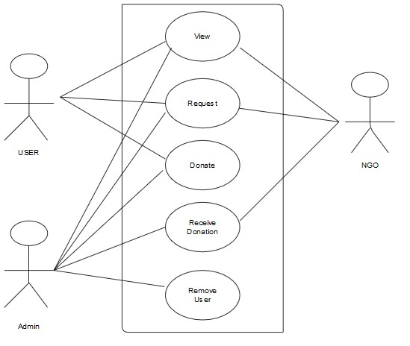

Fig- 5: Use Case Diagram

**4.9 Entity Relationship Diagram**

An **Entity–relationship model (ER model)** describes the structure of a database with the help of a diagram, which is known as **Entity Relationship Diagram (ER Diagram)**. An ER model is a design or blueprint of a database that can later be implemented as a database. The main components of E-R model are: entity set and relationship set.

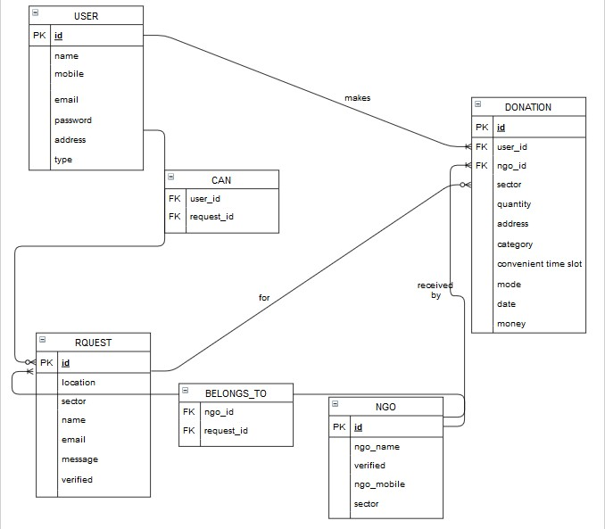

Fig-6 ER Diagram

**4.10 Database schema :**

|  |  |  |
| --- | --- | --- |
| **S.no** | **Collection Name** | **Reason** |
| 1. | User | When user register themselves, then it stores the details. |
| 2. | Ngo | When NGO register themselves, then it stores the details. |
| 3. | Donation | When Donor donates, then it stores the details. |
| 4. | Requests | When user and ngo raise any request, then it store details. |
| 5. | Can | When user raise request, then it store user and request details. |
| 6. | Belongs_to | When ngo raise request, then it store user and request details. |

CHAPTER-5

impementation

The project takes shape during the implementation phase. This phase involves the construction of the actual project result. Programmers are occupied with encoding, designers are involved in developing graphic material, contractors are building, the actual reorganization takes place. It is during this phase that the project becomes visible to outsiders, to whom it may appear that the project has just begun. The implementation phase is the doing phase, and it is important to maintain the momentum. At the end of the implementation phase, the result is evaluated according to the list of requirements that was created in the definition phase. It is also evaluated according to the designs It may be determined whether the trim on the building has been made according to the agreement, or whether the materials that were used were indeed those that had been specified in the definition phase. This phase is complete when all of the requirements have been met and when the result corresponds to the design. Those who are involved in a project should keep in mind that it is hardly ever possible to achieve a project result that precisely meets all of the requirements that were originally specified in the definition phase. Unexpected events or advancing insight sometimes require a project team to deviate from the original list of requirements or other design documents during the implementation of the project. This is a potential source of conflict, particularly if an external customer has ordered the project result. In such cases, the customer can appeal to the agreements that were made during the definition phase.

**5.1 Plans**

The major activities in this phase are cost estimation, schedule and milestone determination , project staffing, quality control plan and controlling and monitoring plans the implementation plan involves :

• Testing to confirm effectiveness

• Detection and Correction of errors

**5.2 Details of modules and their abstraction**

* 1. User module
  2. Ngo module

**5.3 Snapshots(Output Forms):**

**5.3.1 Home page**



Fig-7: Home page(part 1)

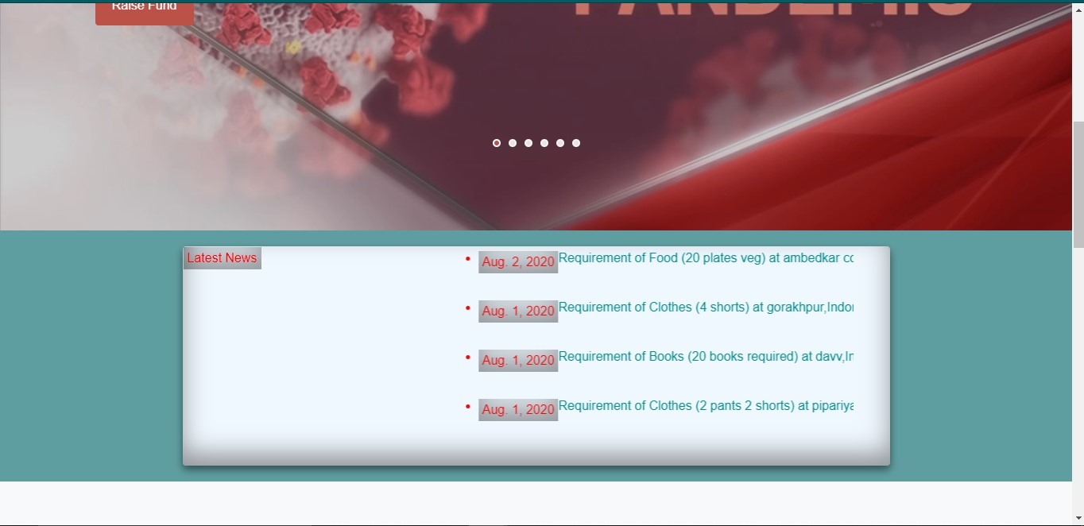

Fig-8: Home page(part 2)

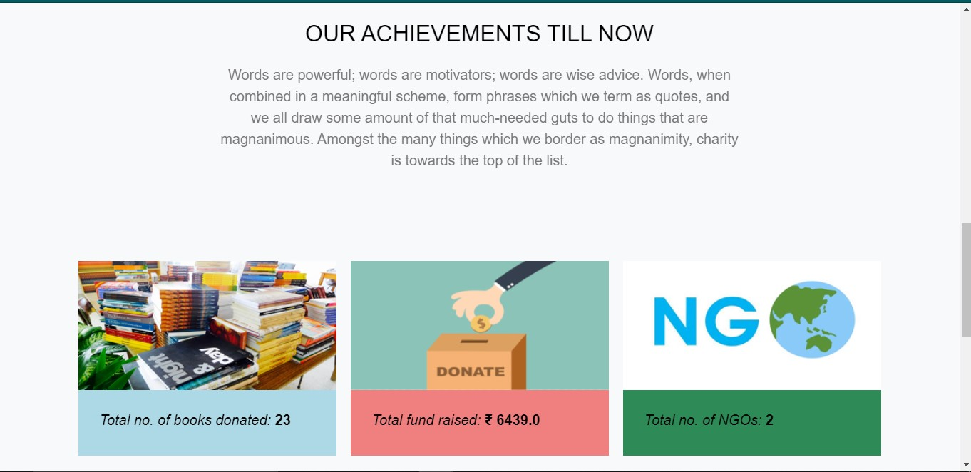

Fig-9: Home page(part 3)

* + 1. **Registration Form(user):**

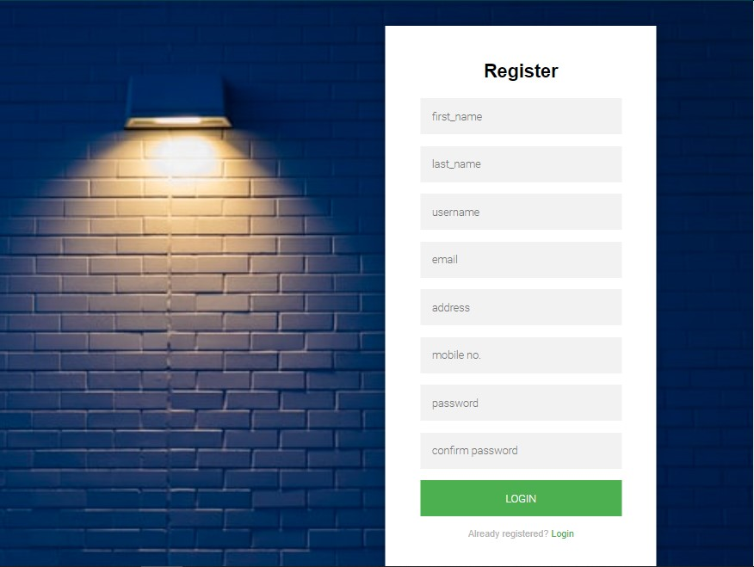

Fig-10: Registration Form(User)

* + 1. **Login form(user):**

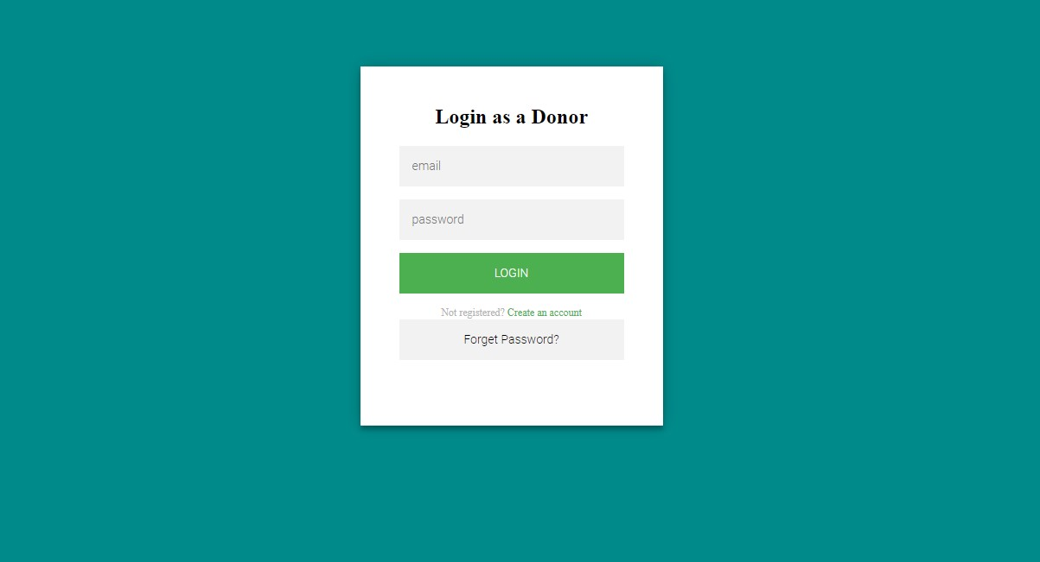

Fig-11: Login Form(Donor)

* + 1. **Registration Form(NGO):**

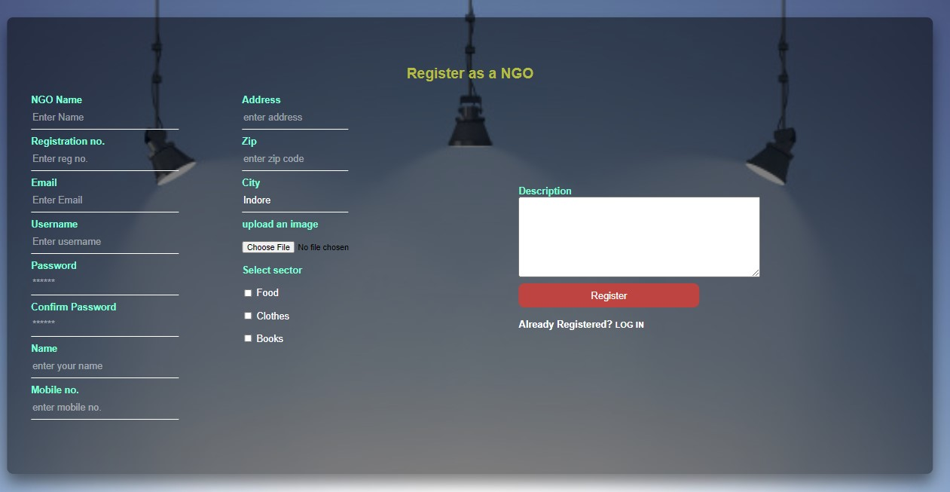

Fig-12: Registration Form(NGO)

* + 1. **Login Form(NGO):**

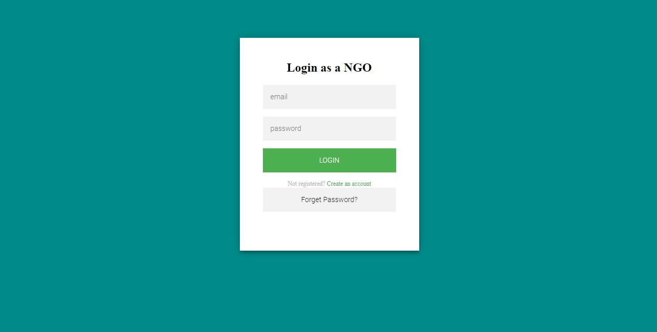

Fig-13: Login Form(NGO)

* + 1. **Forget Password Form(user & ngo):**

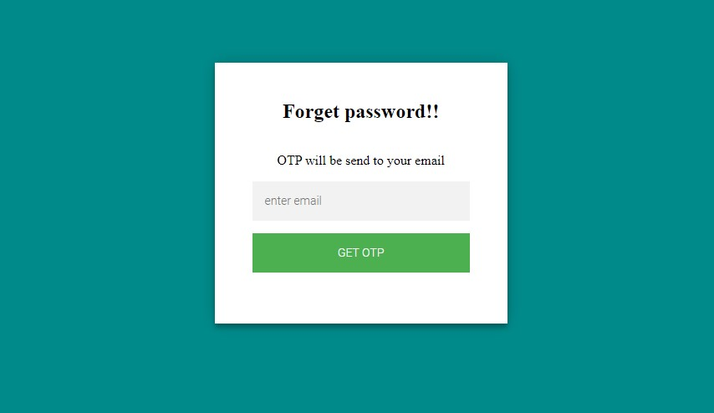

Fig-14: Forget Password Form

* + 1. **OTP verification Form:**

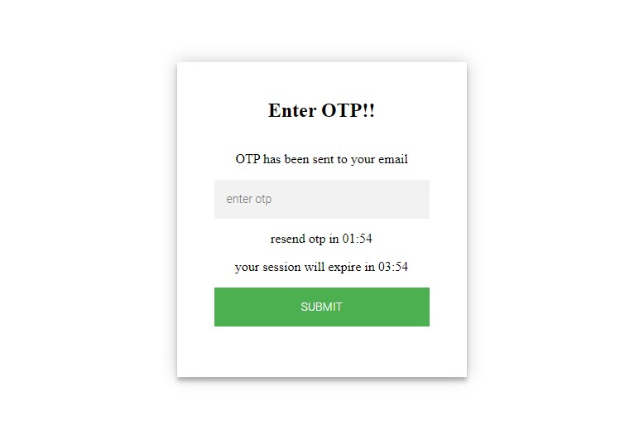

Fig-15: OTP Form

* + 1. **About NGOs Form:**

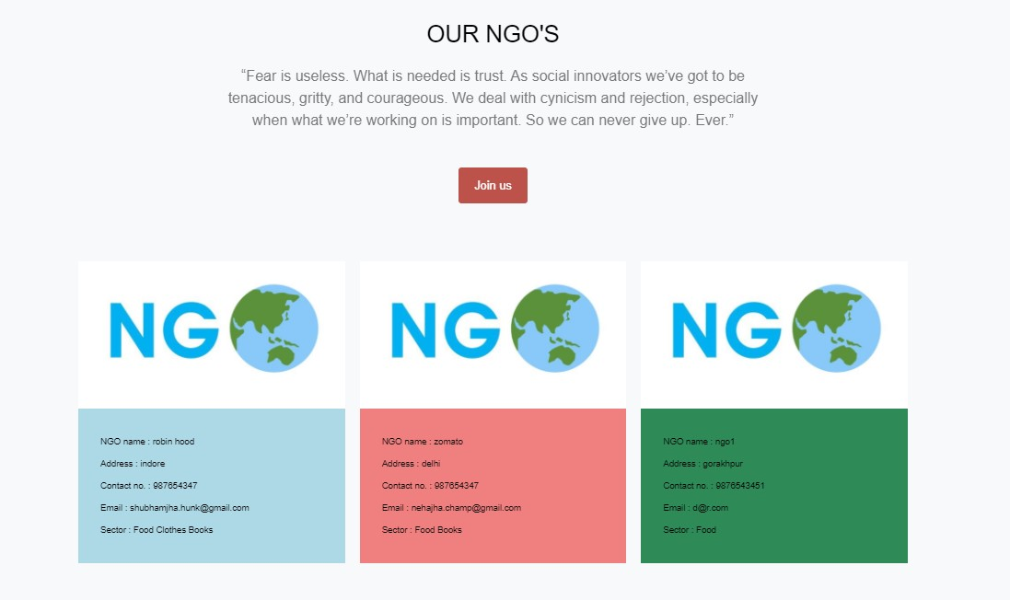

Fig-16: About NGOs Page

* + 1. **User & NGO pannel Form:**

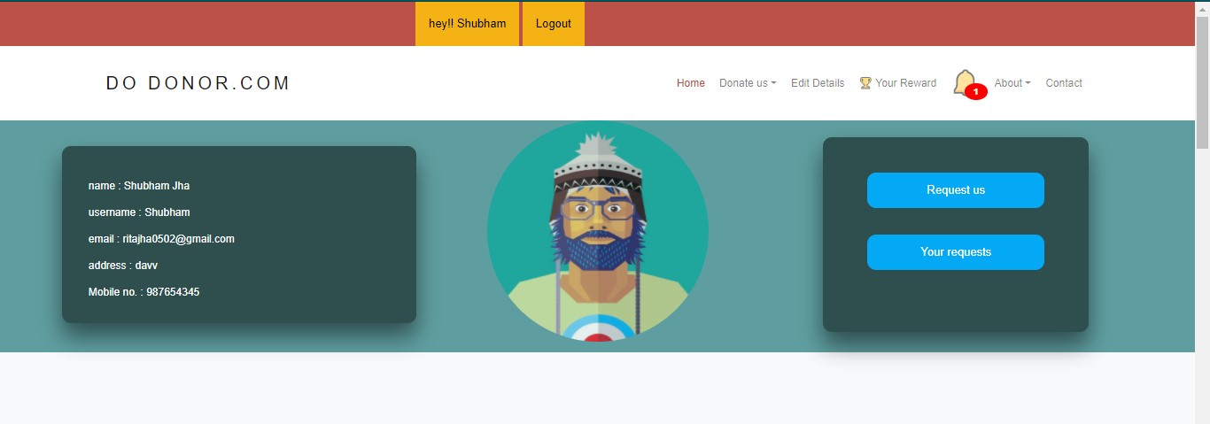

Fig 17: User & NGO pannel (Overview)

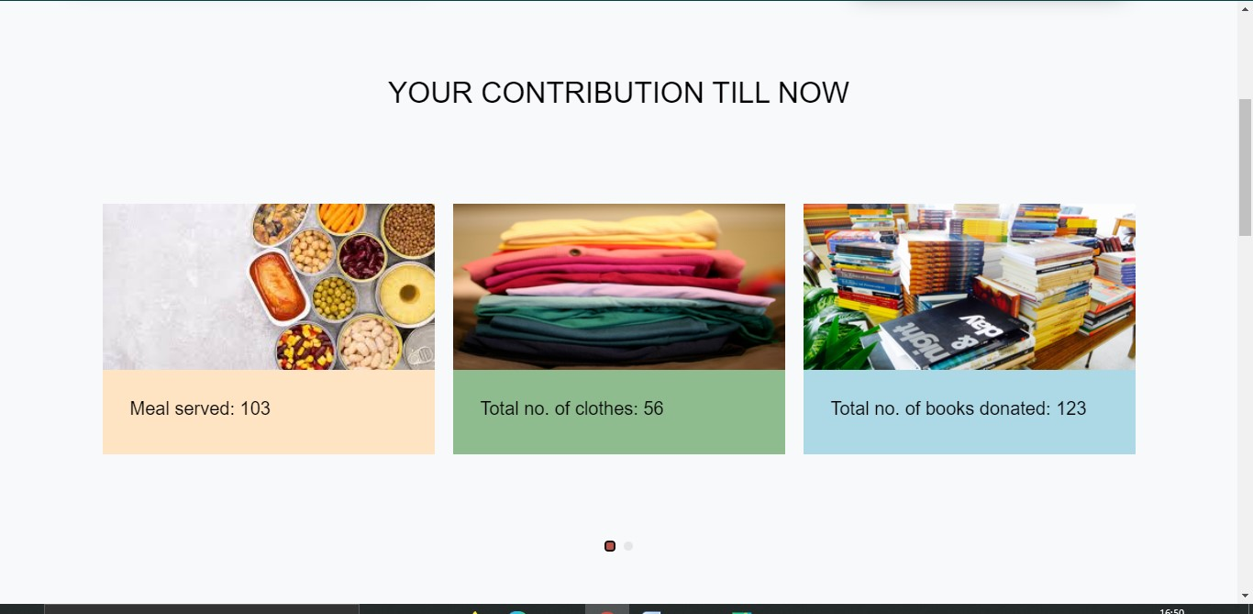

Fig-18: User & NGO pannel (part 2)

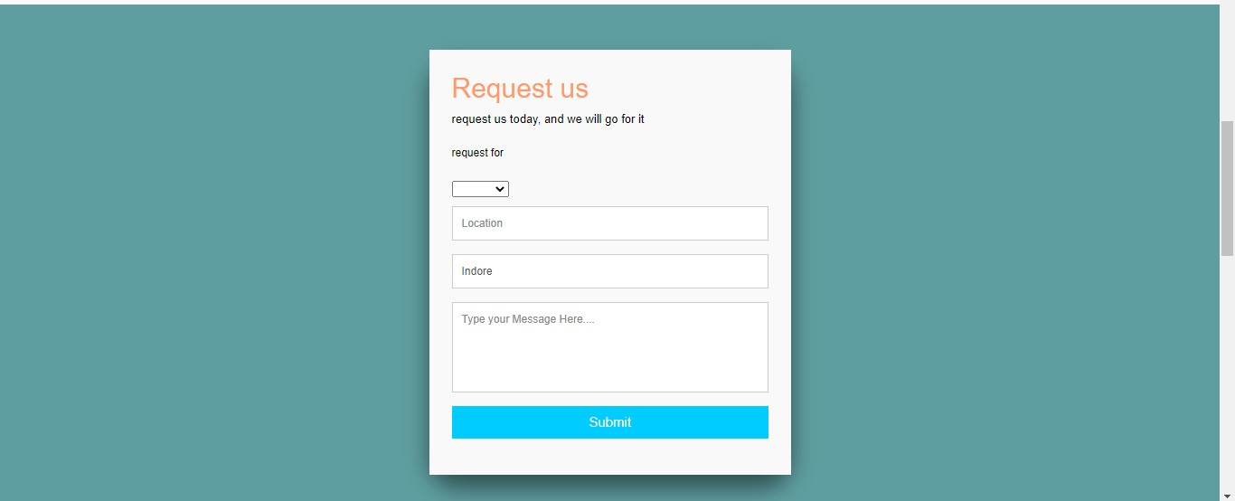

Fig-19: Request Form

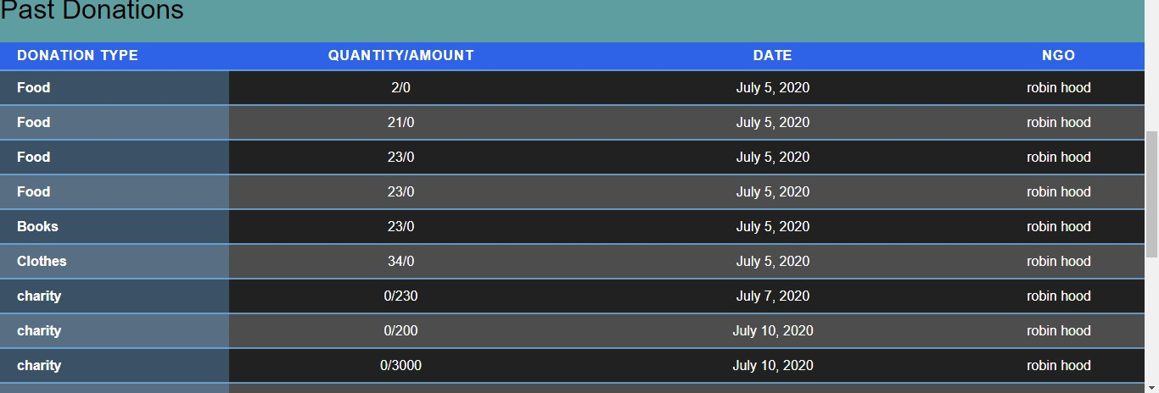

Fig-20: Donation History

* + 1. **Donation Form(Food, Clothes, Books):**

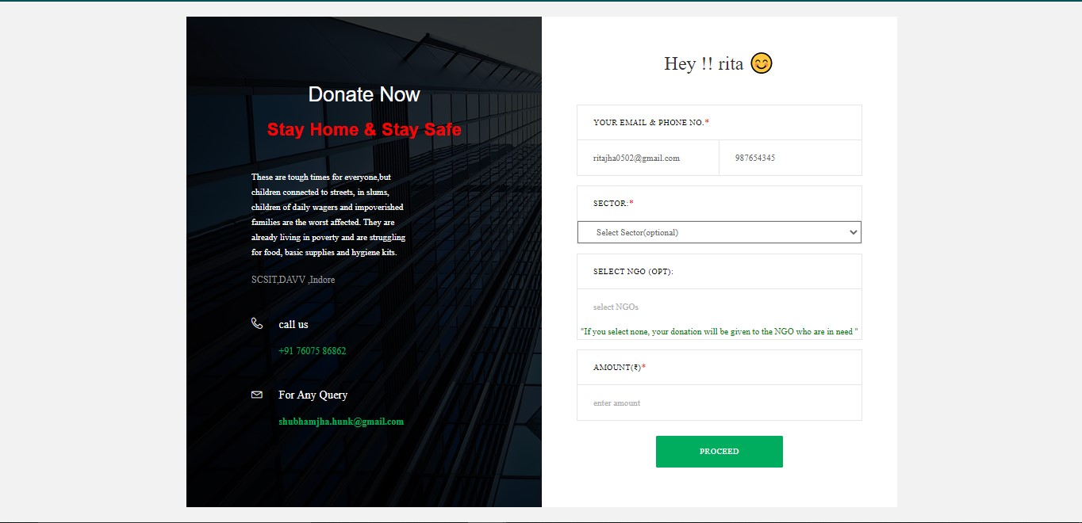

Fig-21: Donation Form

* + 1. **Charity Form:**

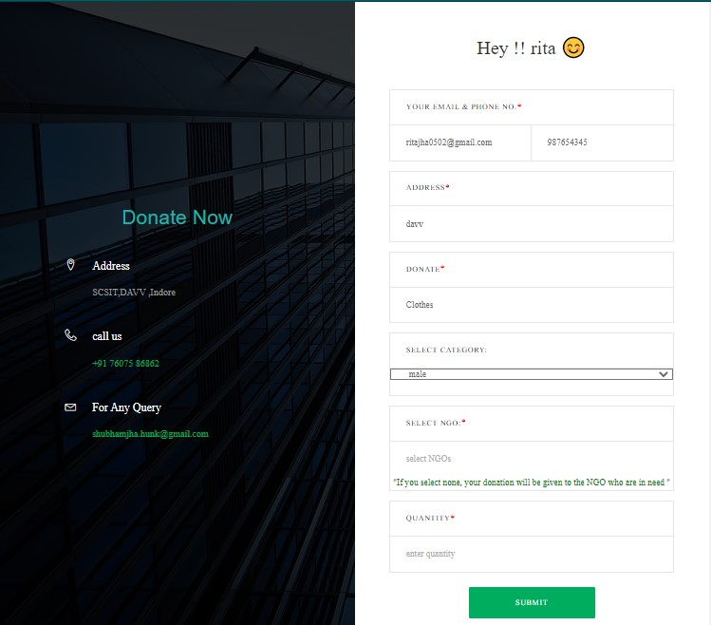

* + 1. **Edit Form(User & NGO):**

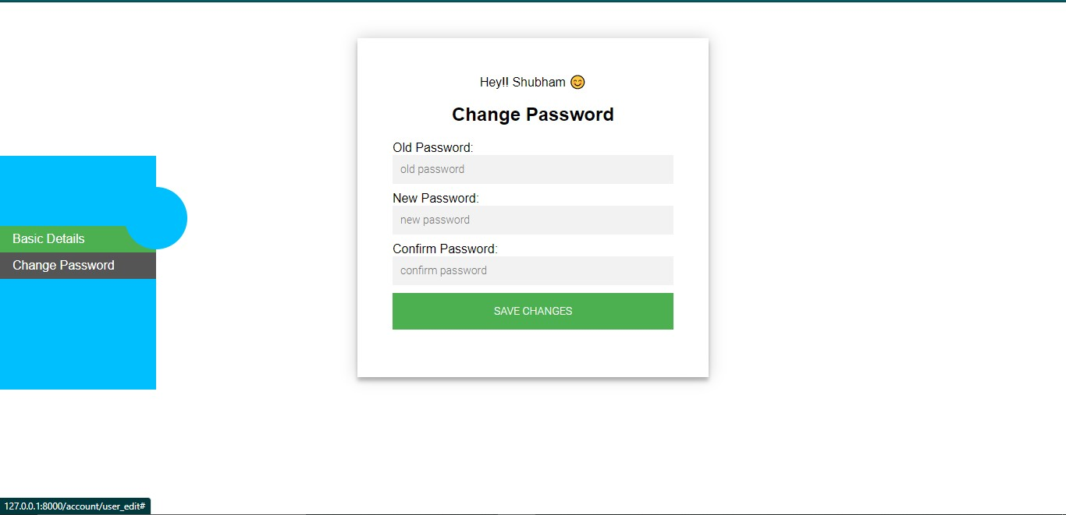

Fig-22: Edit Form(Change Password)

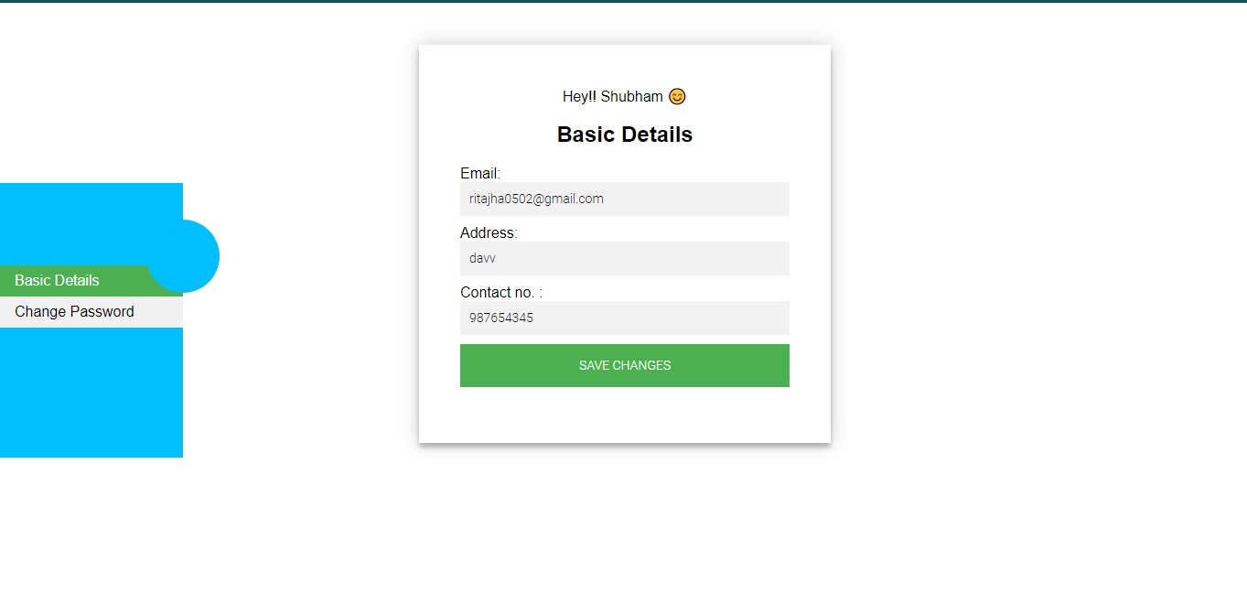

Fig-23: Edit Form(Basic Details)

* + 1. **Notification Page:**

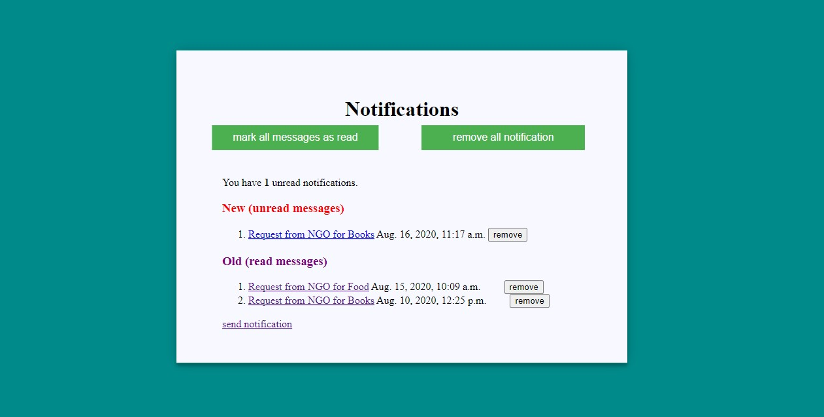

Fig-24: Notification Page

* + 1. **Request Manage Page:**

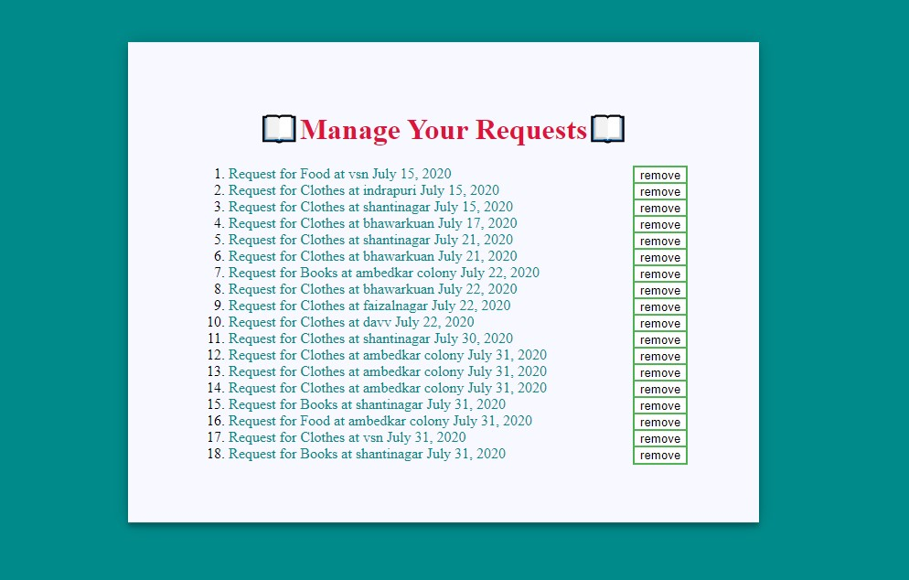

Fig-25: Your Request Page

CHAPTER-6

System testing

Software testing can be stated as the process of verifying and validating that a software or application is bug free, meets the technical requirements as guided by it’s design and development and meets the user requirements effectively and efficiently with handling all the exceptional and boundary cases.

The process of software testing aims not only at finding faults in the existing software but also at finding measures to improve the software in terms of efficiency, accuracy and usability. It mainly aims at measuring specification, functionality and performance of a software program or application.

**Software testing can be divided into two steps:**

**Verification**: it refers to the set of tasks that ensure that software correctly implements a specific function.

**Validation**: it refers to a different set of tasks that ensure that the software that has been built is traceable to customer requirements.

**Verification:** “Are we building the product right?”

**Validation:** “Are we building the right product?”

**What are different types of software testing?**

Software Testing can be broadly classified into two types:

* **Manual Testing**: Manual testing includes testing a software manually, i.e., without using any automated tool or any script. In this type, the tester takes over the role of an end-user and tests the software to identify any unexpected behavior or bug. There are different stages for manual testing such as unit testing, integration testing, system testing, and user acceptance testing.

Testers use test plans, test cases, or test scenarios to test a software to ensure the completeness of testing. Manual testing also includes exploratory testing, as testers explore the software to identify errors in it.

* **Automation Testing:** Automation testing, which is also known as Test Automation, is when the tester writes scripts and uses another software to test the product. This process involves automation of a manual process. Automation Testing is used to re-run the test scenarios that were performed manually, quickly, and repeatedly.

Apart from regression testing, automation testing is also used to test the application from load, performance, and stress point of view. It increases the test coverage, improves accuracy, and saves time and money in comparison to manual testing.

**What are different techniques of Software Testing?**

Software techniques can be majorly classified into two categories:

* **Black Box Testing:** The technique of testing in which the tester doesn’t have access to the source code of the software and is conducted at the software interface without concerning with the internal logical structure of the software is known as black box testing.
* **White-Box Testing:** The technique of testing in which the tester is aware of the internal workings of the product, have access to it’s source code and is conducted by making sure that all internal operations are performed according to the specifications is known as white box testing.

**What are different levels of software testing?**

Software level testing can be majorly classified into 4 levels:

* **Unit Testing:** A level of the software testing process where individual units/components of a software/system are tested. The purpose is to validate that each unit of the software performs as designed.
* **Integration Testing:** A level of the software testing process where individual units are combined and tested as a group. The purpose of this level of testing is to expose faults in the interaction between integrated units.
* **System Testing:** A level of the software testing process where a complete, integrated system/software is tested. The purpose of this test is to evaluate the system’s compliance with the specified requirements.
* **Acceptance Testing:** A level of the software testing process where a system is tested for acceptability. The purpose of this test is to evaluate the system’s compliance with the business requirements and assess whether it is acceptable for delivery.

CHAPTER-7

Conclusion

From a proper analysis of positive points and constraints on the components , it can be safely concluded that the product meets the objective for which it has been developed. This component can be easily fit in many other systems. Also the component is user friendly, Generally the user find difficulty to access the thing manually, like reaching and then donating or contacting. This all process was done manually previously .So there is a need to develop a system that can solve the mentioned problems. This software comes with just that solution .

While completing this project we learnt how to develop application with dynamic database, how information technology management approach is followed in developing of information technology project, how to work in a team and complete the project successfully.

The project gave us valuable experience of how to tackle problems during the development.

Online Donating Site is designed in such a way that it is as user friendly as possible. It has been develop in such a way that is devoid any error and it less time consuming. The system is robust and has provision for future development. So any aspiring user like user can visit the site and will get benefits with least effort. With further enhancement the system can prove to be more efficient than traditional system. As the time is more valuable , so the user or donor communicate with ngos with one click or request .

**7.1 Limitations**

The limitations of Online Donating Site are :

* No gateway method for payment procedure.
* Ngos can’t donate to other ngos through this system.
* User request has to be verified manually by Ngos.
* User can donate only one type of stuff at a time.
* User can only request and donate on the day he/she asks or requests.
* Verification of Ngos would be done manually by admin.

CHAPTER-8

Lesson learned and future scope

**8.1 Lesson Learned:**

Things we learned while making this system are:

* How to use the frameworks like Django to build the site.
* How to implement and automate the system for day to life activties.
* Understanding the needs of end user.
* Sending signals or notifications from one user to multiple user at a time.
* Learned how to use email and otp feature for any process.
* Learned how to manage the database efficienty to reduce the time complexity.

**8.2 Future Scope:**

Online Donating Site can be more effective for the sociecty by:

* Indroducing the gateway method in payment procedure.
* Verification of ngo would be done automatically
* User can donate multiple stuffs at a time.
* Adding a GPS feature for locating the area where there is requirement.
* By expanding the area for user and ngos.

**8.3 REFRENCES**

**Books:**

* [Learn Python the Hard Way (3rd Edition)](http://geni.us/XNd0BY): The J2EE Technology Web Tier, author Jayson Falkner and Kevin Jones.
* Fundamentals of Database Systems, Sixth Edition author Shamkant B. Navathe.

**Websites:**

1. [http://www.stackoverflow.com](http://www.stackoverflow.com/)
2. https://www.geeksforgeeks.org
3. https://docs.djangoproject.com
4. [http://www.w3schools.com](http://www.w3schools.com/)